**Ecosphere**

**Coastal and Marine Ecology**

**Availability of Chinook and Sockeye Salmon as Prey to Cook Inlet Beluga Whales**

Jordy Bernard1, Bill Templin1, Adam Reimer1, Jack Erickson1, Timothy McKinley1, Kalin Kellie2, *Kate Lomac-MacNair3, Megan Blees3, Morgan Bender4, Milo Adkison5, Lori Polasek5, Lori Quakenbush6

1Alaska Department of Fish and Game, 333 Raspberry Road, Anchorage, AK 99518

2Ruby Moon Consulting, 2730 Goldstream Road, Fairbanks, AK 99709

3Owl Ridge Natural Resource Consultants, Inc. 4060 B Street, Suite 200, Anchorage, AK 99503

4Fjord & Fish Sciences, 2475 Sprucewood Street, Anchorage, AK 99508

5Alaska Department of Fish and Game, 1255 W 8th Street, Juneau, AK 99801

6Alaska Department of Fish and Game, 1300 College Road, Fairbanks, AK 99701

*Corresponding author email: [kate@owlridgenrc.com](mailto:kate@owlridgenrc.com)

**Open Research Statement**

[Include statement from ScholarOne submission]

**Key words/phrases**

Cook Inlet beluga, *Delphinapterus leucas,* prey availability, Chinook salmon, *Oncorhynchus tshawytscha,* sockeye salmon, *Oncorhynchus nerka*, fishery management, Cook Inlet, Alaska, integrated population model, predator-prey dynamics.

**Abstract**

Cook Inlet beluga whales (CIBW) are an endangered population of toothed whales in southcentral Alaska that have not shown signs of recovery over the past two decades. Since the 1999 harvest moratorium, the number of whales in the population has remained relatively stable, with the 2022 estimate at 381 whales. Despite extensive research efforts since its Endangered Species Act listing in 2008, the mechanisms limiting population growth remain poorly understood. Recent studies suggest prey availability could be a significant factor limiting reproduction. This study provides information relating to CIBW prey availability and identifies mechanisms that may limit CIBW population growth. We developed a database containing decades of Cook Inlet fisheries data collected by the Alaska Department of Fish and Game. Here we summarize fisheries information archived in the database, estimate annual vital rates of CIBWs using an age-structured integrated population dynamics model, and correlate these vital rates to indices of prey availability (i.e., the annual biomass of select salmon runs). The biomass of Chinook salmon, the first species of salmon to arrive in Cook Inlet to spawn, declined significantly in the late 2000s, however, the biomass of other species, including sockeye, has showed no clear trend since the 1980s. Although there were some indications that CIBW survival rates declined between 2005 and 2017, a period over which the biomass of Chinook and sockeye runs decreased in magnitude, it is not clear, without additional information such as a longer time series on CIBW survival rates and prey abundance, whether an increase in salmon availability would lead to more CIBWs.

**1. Introduction**

Five stocks of beluga whales (*Delphinapterus leucas*) in the U.S. are recognized by the National Marine Fisheries Service (NMFS), all of which are found in Alaskan waters: the eastern Beaufort Sea, eastern Chukchi Sea, eastern Bering Sea, Bristol Bay, and Cook Inlet stocks. Cook Inlet beluga whales (CIBWs) are a geographically (Laidre et al., 2000) and genetically isolated (O’Corry-Crowe et al., 1997) distinct population segment (DPS) found only in Cook Inlet, Alaska. CIBWs are the only beluga stock listed under the U.S. Endangered Species Act (ESA). Although a small, resident group (comprising fewer than 20 individuals) found near Yakutat, Alaska, is recognized as part of the CIBW population under the Marine Mammal Protection Act (MMPA), these whales are not categorized as part of the CIBW DPS under the ESA and are not considered to be part of the CIBW stock within this report. Prior to their decline, CIBWs played a critical role in Alaska Native subsistence and culture and currently are important for tourism, and as a top-level predator in the Cook Inlet ecosystem.

Geographically, Cook Inlet is a semi-enclosed, tidally influenced estuary on the northern boundary of the Gulf of Alaska and adjacent to the largest urban areas of Alaska. Cook Inlet extends northeast to southwest approximately 370 km from Knik and Turnagain arms in the north to Kamishak Bay and the Gulf of Alaska in the south. Cook Inlet commercial activities include fishing, the largest cargo port in Alaska, and oil and gas production from offshore drilling platforms. Here, we reference three geographic areas within Cook Inlet, based on ADF&G fishing districts: the Northern District of Upper Cook Inlet (UCI), the Central District of UCI, and Lower Cook Inlet (LCI) (Figure 1).

Although the CIBW population was historically small, estimated to number over a thousand in the late 1970s and early 1990s (Shelden et al., 2015), population abundance estimates showed a decline of nearly 50% from 1994 to 1998 (Figure 2), due primarily to an unregulated subsistence harvest (Hobbs et al., 2015). In 2000, the stock was designated as depleted under the MMPA (NMFS 2000). Although a harvest moratorium was created in 1999 (Ferrero et al., 2000), CIBWs continued to decline at 2.3% per year during the next 20 years (Shelden & Wade, 2019). In 2008, NMFS listed the CIBW DPS as Endangered under the ESA (73 FR 62919, NOAA, 2008) and Critical Habitat was designated in 2011 (NOAA, 2011). The ESA listing decision attributed the primary cause of decline to unsustainable and unregulated levels of subsistence harvest (Hobbs et al., 2000; Mahoney & Shelden 2000) and noted destruction of habitat, predation by killer whales (*Orcinus orca*), and stranding as additional factors contributing to the population’s decline.

Since 1994, NMFS has conducted annual or biennial aerial surveys in early June to estimate abundance (Goetz et al., 2023). The most recent population estimate, conducted in 2022, is 381 CIBWs (95% credible interval 317 to 473) indicating a 0.2% increase per year over the last ten years (Goetz et al., 2023). Distribution data from the aerial surveys along with a review of satellite tagging and opportunistic sightings has shown that the summer range has contracted substantially (Rugh et al., 2010; Shelden et al., 2015). Historically, CIBWs were distributed throughout Cook Inlet with traditional knowledge documenting beluga presence in the headwaters of Kachemak Bay in LCI and the Kenai River in the Central District of UCI (Huntington 2000). Since the late 1970s, summertime distribution has shifted to the northern end of UCI (Shelden et al., 2015). Between 1978 and 2008, 50% of the population occupied the Susitna Delta, between the Beluga and Little Susitna rivers, and after 2008 it was 83% (Muto et al., 2022). In recent years, during late spring through summer, the entire CIBW population is thought to congregate in areas of UCI to forage (Figure 1; Shelden et al., 2015). Stable isotope analysis of teeth from 20 CIBWs that died between 1964 and 2007 indicates a dietary shift occurred over the past 50 years, potentially involving new freshwater prey species or the same marine prey species from locations with stronger freshwater influences (Nelson et al., 2017). This suggests that CIBWs shift to the northern end of the inlet is the continuation of a trend occurring over the last half-century.

In general, CIBW distribution throughout Cook Inlet is thought to correspond to prey availability (e.g., Huntington 2000; Hobbs et al., 2006; Wolf et al., 2018); although, other factors such as anthropogenic noise (NMFS, 2016) and the presence of marine mammal eating killer whales (Shelden & Rugh, 2003) may influence distribution. A 2008‒2013, year-round, passive acoustic monitoring program monitoring 13 locations within CIBW Critical Habitat has provided a better understanding of the population’s distribution with seasonal differences in foraging habitat preference (Castellote et al., 2020). Foraging behavior was more common during late spring and summer, especially near river mouths of the Beluga and Susitna rivers, coinciding with the presence of anadromous fish runs (Castellote et al., 2020, 2021). However, the peak in beluga presence occurred prior to the Chinook salmon (*Oncorhynchus tshawytscha*) run (Castellote et al., 2021) and was likely related to the eulachon (*Thaleicthys pacificus*) run in the Susitna River.

During winter, foraging behavior persisted at lower levels in lower Knik Arm, Beluga River, Trading Bay, and Tuxedni Bay. Traditional knowledge reports suggest CIBW movements are closely associated with presence of prey (Huntington 2000). Near Tyonek and the Beluga River flats, CIBWs arrive in late April following runs of eulachon and have been reported in large groups (100 to 200 animals) in the Susitna Flats, beginning in late April and early May, where they stay throughout the summer feeding on salmon (Huntington, 2000). Stomach contents of 12 CIBWs collected between April and November 1995–2003 found eulachon and, to a lesser extent, cod (*Gadidae* sp.) were the most abundant fish prey during the early spring (Apr–Jun), while salmon were dominant during late spring and summer (Jul–Sep) (Hobbs et al., 2006). The seasonal shift in CIBWs’ stomach contents aligns with the timing of fish runs, with eulachon primarily occurring in April and May and salmon occurring in May through August. Aerial survey data for CIBWs in 2013 and 2014 found their seasonal distribution matched that of the prey distribution, including eulachon, and salmon in the Susitna and Beluga rivers and Chickaloon Bay, suggesting CIBWs select habitats based on the availability of fish species found in nearshore bays and river mouths (Wolf et al., 2018). However, prey availability alone is unlikely to explain the recent changes in CIBW spatial distribution because some areas of high prey densities (i.e., the Kasilof and Kenai rivers) are no longer used by CIBWs in the summer months (McHuron et al., 2023).

Overall, there is a paucity of information on CIBW diet composition and prey. Most data come from stomach contents of subsistence harvested belugas during 1992‒2012 and dead stranded whales. Traditional knowledge provides important diet information, however mostly for spring and summer months. Stomach content analysis found, chum (*Oncorhynchus keta*), and coho (*Oncorhynchus kisutch*) salmon within the stomachs of CIBW along with saffron and Pacific cod (*Eleginus gracilis* and *Gadus macrocephalus*), walleye pollock (*Gadus* *chalcogramma*), eulachon, starry flounder (*Platichthys stellatus)* and yellowfin sole (*Limanda aspera*; Huntington 2000; Hobbs et al., 2006; Quakenbush et al., 2015). Invertebrate prey (e.g., shrimp, polychaetes, and amphipods) were also found, however less commonly than in other Alaska beluga stocks. Eulachon and Pacific cod were exclusively found in CIBW diet and not in other Alaska stocks (Quakenbush et al., 2015). Traditional knowledge suggests CIBWs prefer sockeye salmon (*Oncorhynchus nerka*), and that Pacific herring (*Clupea pallasii*) is an additional source of prey (Huntington, 2000). Although sockeye salmon and Pacific herring have been found in stomach contents of other stocks of beluga whales, they have not been identified in CIBWs’ (Quakenbush et al., 2015); however, in many cases, identifying salmon to species from their small otoliths, that degrade easily in beluga stomachs, is not possible (Quakenbush et al. 2015).

Summer feeding is believed to be very important to CIBW. When they arrive in UCI in the spring, their blubber is approximately 2–3 inches thick, but by fall, it can reach up to 1 foot thick (Huntington, 2000). For Bristol Bay belugas, the only other known resident beluga population in Alaska (excluding Yakutat whales) blubber mass has been shown to be lower in the spring and higher in the fall (Cornick et al., 2016). Such fluctuations in blubber mass suggest that summer prey, particularly anadromous fish, may influence the size of these beluga populations.

Records of shellfish, fish, and marine mammal harvests in Cook Inlet have been kept for more than a century. The Alaska Department of Fish and Game (ADF&G) manages the harvest of marine and freshwater fish and shellfish in Cook Inlet through commercial, sport, subsistence, and personal use fisheries. Fishery management follows a sustained yield principle of harvest, which is provided in Alaska law through management plans that dictate season, gear type, periods, areas, bag limits, requirements for participation and reporting, abundance thresholds (i.e., escapement goals), and monitoring efforts specific to each targeted stock. Research and monitoring efforts by ADF&G are salmon-centric and provide information on escapement, harvest, age-composition, fish size, and in-season run timing. Data from certain stocks undergo additional statistical analysis and modeling to estimate the total number of salmon returning to a drainage (e.g., total run size; Fleishman & Reimer 2017). If biological data are insufficient for a species, harvest levels are conservative.

Within UCI, all five species of Pacific salmon (Chinook, chum, coho, pink, and sockeye), herring, eulachon, and razor clams (*Siliqua patula*), are commercially harvested (Marston & Frothingham, 2022). The majority of the commercial harvest in UCI consists of sockeye salmon from the Central District. Between 1970 and 2020, the annual average commercial harvest across all salmon species in UCI was approximately 4 million fish, with sockeye salmon comprising 73% of the total).

ADF&G's primary monitoring activities center on Chinook and sockeye salmon, providing annual run size estimates for these species for several major tributaries of Cook Inlet. For river systems in UCI with significant salmon runs (> 25,000 fish on average), Chinook salmon run sizes have been estimated for the Susitna and Kenai rivers and sockeye salmon run sizes have been estimated for the Susitna, Kasilof, and Kenai rivers. In contrast, data on chum, coho, and pink salmon availability are notably scant. The turbid waters of Cook Inlet preclude the use of aerial surveys to quantify herring, resulting in sparse data on their availability (Marston & Frothingham, 2022). In UCI, commercial herring and eulachon harvest records are available after 1978. The biomass of spawning eulachon was only estimated for 2016 for the Susitna River (Willette & DeCino, 2023). Some harvest data exist for sport, personal use, and subsistence fisheries around Cook Inlet for all five species of salmon, herring, eulachon, lingcod (*Ophiodon elongatus*), rainbow trout (*Oncorhynchus mykiss*), Dolly Varden (*Salvelinus malma*), Arctic char (*Salvelinus alpinus*), halibut (*Hippoglossus stenolepis*), razor clams, Tanner crab (*Chionoecetes bairdi*) and Dungeness crab (*Metacarcinus magister*).

Outdated and limited information on CIBW diet composition and prey availability greatly restricts an understanding of potential factors limiting recovery (Ezer et al., 2008; Norman et al., 2020). Cause of death for 22 CIBWs found dead during 1998–2013 included stranding (41%), trauma (31%), disease (14%), and malnutrition (14%) (Burek-Huntington et al., 2015). This information suggests that multiple factors influence the population dynamics of CIBWs, and poor nutrition may contribute to the population’s lack of recovery. Along with changes in prey abundance, quality, or availability, several other hypotheses for CIBW population decline and lack of recovery exist including anthropogenic activity and noise (McGuire et al., 2020a; Castellote et al., 2018), oil and gas activities, disease, habitat disturbance, endocrine disruption via pollution, cumulative effects of multiple stressors (NMFS, 2016; Migura & Harry, 2023), and recent changes in marine climate including the 2014‒2016 Pacific marine heatwave (Arimitsu et al., 2021). However, the NMFS 2016 recovery plan highlights key data gaps including habitat use, prime foraging areas, diet, and prey availability (NMFS, 2016). Understanding the linkages between CIBWs and their prey is critical for promoting the recovery of this species while maintaining harvests for commercial, sport, personal use, and subsistence fisheries.

The objective of our study was to identify possible links between CIBW reproduction, survival, and prey availability. We compiled fisheries data from Cook Inlet and developed quantitative indices reflecting the availability of select CIBW prey species in UCI. We analyzed these indices relative to CIBW vital rates. Finally, we highlighted critical data gaps and developed prey-related hypotheses to direct future research efforts to aid in the recovery of CIBWs.

**2. Methods**

To address our objective to investigate possible links between CIBW population parameters and prey availability, we:

1. Compiled available fisheries data within Cook Inlet into a database.
2. Developed annual indices of potential prey availability for fish species where reliable information was available.
3. Estimated key CIBW population parameters including reproductive and survival rates using data on abundance, derived from aerial surveys, and data on age-structure, derived from photo-identification surveys.
4. Correlated CIBW population parameters with indices of potential prey availability.

**2.1 Cook Inlet Fisheries Database**

We compiled fish harvest, escapement, and survey data collected by ADF&G Commercial and Sport Fisheries Divisions and by other sources within ADF&G to create the Cook Inlet fisheries database. Data from sources outside ADF&G, such as private aquaculture, military, and industry were also included. Data analysis was done using Microsoft Excel, R (R Core Team 2022), and Microsoft Access. Processed data were imported into a Microsoft Access database.

**2.2 Indices of Prey Availability**

We used annual run size and fish size data to establish indices of Chinook and sockeye salmon availability within the Northern and Central Districts of UCI. ADF&G’s run size estimates are calculated by combining harvest numbers with fish passage estimates, which are derived using various methods. For each fish species and geographic region, the estimated biomass of major salmon runs was used as an index of prey availability. We used biomass instead of abundance as an availability index to accommodate variations in fish size over time and facilitate comparison among fish species of different sizes. Data were not available to do the same for chum, coho, and pink salmon or for other important prey species, such as eulachon and herring. For this reason, we could not develop quantitative indices of prey availability for prey species other than Chinook and sockeye salmon. Because CIBWs do not inhabit LCI during the summer months and the highest densities of anadromous prey are believed to occur in the Northern and Central Districts, we did not develop prey availability indices for LCI fish.

For Chinook salmon, run size (i.e., fish abundance) has been estimated for two major river systems in UCI. In the Central District, the size of the Chinook run has been estimated for early and late-run Chinook salmon for the Kenai River from 1986 to 2021, using capture-recapture and sonar-based methods (Fleischman & Reimer 2017). The early-run occurs from early May to June 30, whereas the late-run occurs from July 1 to late August. Run sizes of early and late-run Chinook salmon returning to the Kenai River demonstrates a strong correlation, with a Pearson correlation coefficient of 0.95 between 1986 to 2021, which is significantly different from zero (p-value = ${2.2}^{-16}$). Due to similar trends in run size over time for early and late Kenai Chinook salmon, these runs were combined in this analysis. In the Northern District, the size of the Chinook run has been estimated for the Susitna River from 1979 to 2022, using capture-recapture and aerial survey-based methods (Reimer & DeCovich, 2020). For the Kenai River, run size has been estimated using large Chinook salmon only (75 cm mideye-to-tail-fork-length and longer); and for the Susitna River, run size has been estimated using all lengths of Chinook salmon. The 75 cm cutoff is used on the Kenai River to distinguish Chinook from sockeye salmon and simplify run apportionment.

For sockeye salmon, run size has been estimated for three major river systems in UCI: the Kasilof River (1968–2016) and the Kenai River (1968–2015) in the Central District using sonar-based methods; and for the Susitna River (2006–2015) in the Northern District (Figure 3) using capture-recapture based methods. Although a significant sockeye salmon run exists in Fish Creek in the Northern District, we did not include it in our analysis because it is small compared to the Susitna River sockeye salmon run and run size estimates are not vetted.

There has been a documented decline in the body size of Chinook, chum, coho, and sockeye salmon. Comparing mean body length before 1990 to mean body length after 2010, statewide, Chinook salmon length has declined the most, averaging 8.0% followed by 3.3% for coho, 2.4% for chum, and 2.1% for sockeye (Oke et al., 2020). In UCI, the mass of Chinook salmon in the commercial harvest has decreased at an average rate of 0.31 pounds per year during 1975‒2021 (Marston & Frothingham, 2022); however, the mass of chum, coho, pink, and sockeye salmon has remained relatively stable over this period (Figure 4).

Given the notable decline in the length and biomass of returning Chinook salmon over time, we employed mass-at-age by year data to account for variations in size over time when estimating the biomass of Chinook salmon runs for the Kenai and Susitna rivers. The data that we used to estimate the biomass of major Chinook salmon runs are outlined below:

* $N_{y,r}^{(c)}$: The abundance of the Chinook salmon run during year $y for river r$. This can be seen in the top panel of Figure 3.
* $q_{y,r,a}^{\left(c\right)}$: The proportion of age- $a$ Chinook salmon that return to river $r$ during year $y$.
* $m_{a}^{\left(c\right)}$: The average mass of an age- $a$ Chinook salmon in Cook Inlet. Here, $m_{a}^{\left(c\right)}$ was estimated using age-length data from the Deshka River, a tributary of the Susitna River, where these data are available, in combination with the length-mass relationship presented in Oke et al. (2020).

To estimate the annual biomass of Chinook salmon runs, we assumed that all sizes of Chinook salmon are equally likely to be commercially harvested, that Deshka River age-length data is representative of all UCI Chinook, and that the length-mass relationships of Oke et al. (2020) apply to UCI Chinook. Within equations, superscripts differentiate model parameters or variables. For instance, $N_{y,r}^{(c)}$ represents Chinook abundance, while $N_{y,r}^{\left(s\right)}$ ​ represents sockeye abundance. The biomass of the Chinook salmon run for year $y$ on river $r$ was calculated using the following equation:

$$\begin{aligned}B_{y,r}^{\left(c\right)}=\sum_{a}{N_{y,r}^{\left(c\right)}q_{y,r,a}^{\left(c\right)}m_{a}^{\left(c\right)}} \# Equation 1\end{aligned}$$

We assumed that fish size of returning sockeye salmon has remained constant over time when estimating the biomass of sockeye salmon runs for the Kasilof, Kenai, and Susitna rivers. The data that we used to estimate the biomass of major sockeye salmon runs is outlined below:

* $N_{y,r}^{\left(s\right)}:$ The abundance of the sockeye salmon run during year $y$ on river $r$. This can be seen in the bottom panel of Figure 3.
* $m^{\left(s\right)}$: The average mass of a Cook Inlet sockeye salmon, which was estimated using data from commercially harvested sockeye salmon from Cook Inlet between 1975 and 2021 (Marston & Frothingham, 2022).

The biomass of the sockeye salmon run during year $y$ on river $r$ was estimated using the following equation:

$$\begin{aligned}B_{y,r}^{\left(s\right)}=N_{y,r}^{\left(s\right)}m^{\left(s\right)} \# Equation 2\end{aligned}$$

The indices of prey availability that we developed are described in Table 1 and shown in Appendix S1: Table S2.

Although not modeled, catch-per-unit effort (CPUE) data for chum, coho, and pink salmon from an offshore test fishery (OTF), located at the boundary between UCI and LCI (Figure 1), were summarized to provide insight into these species. The primary objective of the OTF is to collect in-season data to assess the timing and magnitude of the sockeye salmon run in July. While evaluating chum, coho, and pink salmon runs is not the focus of the OTF, data on their relative July run strength are documented.

**2.3 CIBW Population Parameters**

To estimate vital rates (i.e., survival and reproduction rates) of CIBWs annually in an age-structured manner, an integrated population dynamics model (IPM) with a state-space framework was used. By simultaneously modeling reproduction, survival, and abundance, estimated demographic parameters are informed by multiple data sources and ensured to be internally consistent. The model was fit to two sources of data on beluga survival and reproduction over time: 1) NMFS estimates of population abundance, derived from aerial surveys between 2005 and 2018 (Goetz et al., 2023), and 2) estimates of the proportion of young-of-year (YOY) calves, and adults, derived from photo-identification mark recapture data between 2005 and 2017 (Appendix S2; Himes Boor et al., 2022). Without information on age-class composition, obtained from photo-identification mark-resight data, it is not feasible to estimate vital rates with any reasonable level of precision. Although data on population abundance are available from 1994 to 2022, survival and reproduction rates can only be reliably estimated for the period between 2005 and 2017. The data used to fit the model are provided in Appendix S1: Table S3.

Uncertainty in the data used to fit the model is passed to the survival and reproduction rates estimated by the model, which allows for a realistic assessment of what is known and what is not known. The state-space model is described by two processes: (1) the latent process is a mathematical description of the population dynamics of CIBWs, and (2) the observation process relates the data to the latent process, which allows the variables and parameters described in the latent process to be estimated.

**Latent Process**

The latent process describes how population size relates to reproduction and survival. In developing the mathematical framework of the model, let $y=1, 2, ⋯, n^{(y)}$ be an index that represents the year. Additionally, let $a$ be an index representing the age class, where $a=1$ corresponds to YOY belugas; $a=2$ corresponds to calves that are not YOY (henceforth referred to as calves); and $a=3$ corresponds to adults. From an interpretative perspective, these age classes align with how photo-ID data are recorded: YOY with adults, calves with adults, and adults. Consequently, the term "adult" does not necessarily imply sexual maturity, as some whales may have separated from their mothers before reaching reproductive age. Sexes are pooled across all age classes. The latent variables and parameters contained in the latent process are defined in Table 2.

Equations 3‒5 describe the latent process. These equations are based on CIBW biology and population monitoring data. Equation 3 asserts that the number of YOY belugas during any given year is equal to the number of mature females $\left(\frac{N_{y,3}^{\left(a\right)}}{2}\right)$ multiplied by the reproduction rate ($p_{y}^{\left(r\right)}$), which is specific to mature females. Mathematically this is expressed as follows:

$$\begin{aligned}N_{y,1}^{(a)}=\frac{N_{y,3}^{\left(a\right)}}{2}p_{y}^{\left(r\right)}\#Equation 3\end{aligned}$$

This equation assumes a 1:1 adult sex ratio. Of 50 CIBWs harvested from Cook Inlet between 1989 and 2005 with known sexes (Burek-Huntington et al., 2022), 44% were female (95% CI: 0.30-0.59).

The next two equations describe how the abundance of calves and adults evolves over time:

Equation 4 asserts that the abundance of calves during the next year is equal to the number of YOY belugas that survive to next year plus the number of calves that are not YOY, that survive to the next year but do not mature:

$$\begin{aligned}N_{y+1,2}^{\left(a\right)}=N_{y,1}^{\left(a\right)}p_{y,1}^{\left(s\right)}+N_{y,2}^{\left(a\right)}p_{y,2}^{\left(s\right)}\left(1-ϕ_{y}\right)\#Equation 4\end{aligned}$$

Equation 5 asserts that the abundance of adults the next year is equal to the number of calves that survive to the next year and are recruited into the adult population plus the number of adults that survive to the next year: $\begin{aligned}N_{y+1,3}^{\left(a\right)}=N_{y,2}^{\left(a\right)}p_{y,2}^{\left(s\right)}ϕ_{y}+N_{y,3}^{\left(a\right)}p_{y,3}^{\left(s\right)}\#Equation 5\end{aligned}$

Equations 6 and 7 calculate key parameters that allow the model to be fit to information on population abundance, coming from June aerial surveys, and information on age composition, derived from photo-identification mark-resight data. Equation 6 asserts that the population abundance in June is equal to the combined calf and adult beluga abundance. It is assumed that calving occurs after the June aerial surveys are conducted and that YOY beluga are not included in the estimate: $\begin{aligned}N_{y}^{\left(t\right)}=N_{y,2}^{\left(a\right)}+N_{y,3}^{\left(a\right)}\#Equation 6\end{aligned}$

Equation 7 calculates the proportion of belugas in each age class from the abundance of belugas in each age class after calving has occurred:

$$\begin{aligned}p_{y,a}^{\left(a\right)}=\frac{N_{y,a}^{\left(a\right)}}{N_{y,1}^{\left(a\right)}+N_{y,2}^{\left(a\right)}+N_{y,3}^{\left(a\right)}}\#Equation 7\end{aligned}$$

Equations 8 to 11 were used to calculate aggregate statistics relating to CIBW survival and reproduction between 2005 and 2017. The average annual mature female reproduction rate was calculated according to Equation 8:

$$\begin{aligned}p_{ ∙}^{\left(r\right)}=\frac{1}{n^{\left(y\right)}}\sum_{y=1}^{n^{(y)}}{p_{y}^{\left(r\right)}}\#Equation 8\end{aligned}\begin{aligned}\#Equation 8\end{aligned}$$

Next, the population level rate of survival was calculated using Equation 9:

$$\begin{aligned}p_{y, ∙}^{\left(s\right)}= \frac{p_{y,1}^{\left(s\right)}N_{y,1}^{\left(a\right)}+p_{y,2}^{\left(s\right)}N_{y,2}^{\left(a\right)}+p_{y,3}^{\left(s\right)}N_{y,3}^{\left(a\right)}}{N_{y,1}^{\left(a\right)}+N_{y,2}^{\left(a\right)}+N_{y,3}^{\left(a\right)}} \#\text{ Equation} 9\end{aligned}$$

Finally, the average annual survival rate by age class and the overall average survival rate across all age classes were calculated according to Equations 10 and 11, respectively:

$$\begin{aligned}p_{∙, a}^{\left(s\right)}=\frac{1}{n^{\left(y\right)}}\sum_{y=1}^{n^{\left(y\right)}}{p_{y,a}^{\left(s\right)}} \# \text{Equation} 10\end{aligned}$$

$$\begin{aligned}p_{∙, ∙}^{\left(s\right)}=\frac{1}{n^{\left(y\right)}}\sum_{y=1}^{n^{\left(y\right)}}{p_{y,∙}^{\left(s\right)}} \# \text{Equation }11\end{aligned}$$

**Observation Process**

The observation process relates population monitoring data to parameters described within the latent process, which allows the model to be fitted. The specific data used to fit the model is described in Table 3. Equation 12 relates the estimated June population abundance to the true June population abundance:

$$\begin{aligned}{\hat{N}}_{y}^{\left(t\right)}∼Norm\left(N_{y}^{\left(t\right)},\hat{SD}\left({\hat{N}}_{y}^{\left(t\right)}\right)\right)\#Equation 12\end{aligned}$$

Equation 13 relates the estimated end-of-summer age composition to the true end-of-summer age composition and utilizes estimated age class proportions:

$$\begin{aligned}{\hat{p}}_{y,a}^{\left(a\right)}∼Norm\left(p_{y,a}^{\left(a\right)},\hat{SD}\left({\hat{p}}_{y,a}^{\left(a\right)}\right)\right)\#Equation 13\end{aligned}$$

These proportions were estimated using photo-identification mark-resight data from 2005 and 2017 (Himes Boor et al., 2022), and the methods used to estimate these proportions are outlined in Appendix S2.

**Priors**

Bayesian analysis requires that the prior distribution of model parameters be specified. An informative prior was placed on the mature female rate of reproduction, $p_{y}^{\left(r\right)}$. The inter-birth interval for CIBWs has been found to range from 2 to 13 years using photo-identification data (McGuire et al., 2020b). Our model assumes that the male-to-female ratio of CIBWs is 1:1 and that belugas cannot give birth in consecutive years as expressed by Equation 14:

$$\begin{aligned}p_{y}^{\left(r\right)}∼Unif\left(0,\frac{1}{2}× \frac{1}{2}\right)\#Equation 14\end{aligned}$$

A non-informative $Unif\left(0,1\right)$ prior was placed on the proportion of belugas that survive by age class ($p_{y,a}^{\left(s\right)}$) and the proportion of calves that mature annually ($ϕ_{y}).$

**Sensitivity Testing**

The abundance estimates used in our analysis are raw estimates, meaning that a weighted moving average was not applied to smooth these values. To assess how estimated vital rates are influenced by specific population abundance estimates, we also implemented a version of the model using smoothed estimates of CIBW abundance, which have smaller standard deviations, as reported in Goetz et al. (2023).

**Computational Details**

The R programming language was used to build the IPM. We used a custom Markov Chain Monte Carlo (MCMC) routine to estimate the model parameters using the Metropolis Hastings algorithm. The model code can be accessed through the following link: https://github.com/jordy-bernard-ADFG/Availability-of-Chinook-and-Sockeye-Salmon-as-Prey-to-Cook-Inlet-Beluga-Whales. The final model was run on four chains for 10,000,000 MCMC iterations with a thinning interval of 10,000 iterations. All model parameters converged (R-hat < 1.05).

**2.4 Correlation Analysis**

To investigate whether CIBW numbers could be influenced by salmon abundance, we examined the correlation between the mature female rate of reproduction ($p_{y}^{\left(r\right)}$) and the survival rate across the entire population ($p_{y, ∙}^{\left(s\right)}$) with our developed prey availability indices. We focused on tests that most closely align with the biological mechanisms believed to be in effect. In identifying the biological mechanisms most relevant to CIBW survival and reproduction, we considered the following:

* CIBWs are believed to mate in late winter and spring (Lomac-MacNair et al., 2015);
* CIBWs give birth in the summer of the next year following conception (Huntington, 2000); and,
* CIBWs accumulate an energy surplus during the summer to offset an energy deficit during the winter (Huntington, 2000).

A fetus must survive one winter—considered the critical season from an energy perspective—to develop into a viable calf. Therefore, beluga reproduction is most closely linked to prey availability from the previous year (lag-1 correlation).

The relationship between beluga survival and prey availability is more complex. Belugas store energy as blubber, and lactation places additional energy demands on reproductive females. Consequently, prey availability can have lasting effects. However, for practical purposes, the most relevant measure is the correlation between prey availability in a year and the survival rate to the next year (unlagged correlation).

When computing correlation coefficients, we used all data where a reproductive rate could be calculated, and an index of prey availability that was available for the previous year. The specific variables included:

* The mature female rate of reproduction between 2005 and 2017 and the biomass of annual Chinook run sizes for the Susitna River between 2004 and 2016.
* The mature female rate of reproduction between 2005 and 2017 and the biomass of annual Chinook run sizes for the Kenai River between 2004 and 2016.
* The mature female rate of reproduction between 2007 and 2016 and the biomass of annual sockeye run sizes for the Susitna River between 2006 and 2015.
* The mature female rate of reproduction between 2005 and 2016 and the biomass of annual sockeye run sizes for the Kenai and Kasilof rivers between 2004 and 2015.

Additionally, when computing correlation coefficients, we used all available data from years where both a beluga survival rate or reproduction rate and an index of prey availability were available. The specific variables we correlated included:

* Probability of surviving to the next year and the biomass of annual Chinook run sizes for the Susitna River between 2005 and 2017.
* Probability of surviving to the next year and the biomass of annual Chinook run sizes for the Kenai River between 2005 and 2017.
* Probability of surviving to the next year and the biomass of annual sockeye run sizes for the Susitna River between 2006 and 2015.
* Probability of surviving to the next year and the biomass of annual sockeye run sizes for the Kenai River between 2005 and 2015.

Results were summarized using a Bayesian strength-of-evidence approach. Inverse cumulative posterior distributions were used to evaluate the probability that the correlation between two variables exceeded any value. It should be noted that we did not account for uncertainty in prey availability in our correlation analysis; fixed estimates of prey biomass were utilized in correlation coefficient calculations.

**3. Results**

**3.1 Trends in Salmon Biomass and Run Size**

Chinook salmon biomass is markedly lower than sockeye salmon biomass in UCI, with a higher proportion of Chinook salmon returning to the Susitna River compared to the Kenai and Kasilof rivers. Between 2006 and 2015, the average annual biomass of Susitna Chinook salmon was 448 metric tons, compared to 1,169 metric tons of Susitna sockeye salmon, resulting in a Chinook-to-sockeye biomass ratio of 0.38. For the Kenai River, between 1986 and 2015, the average annual biomass was 288 metric tons of Chinook salmon and 9,680 metric tons of sockeye salmon, resulting in a Chinook-to-sockeye biomass ratio of 0.03. It is important to note that the statistics above include all Chinook salmon, regardless of size, for the Susitna River, whereas only Chinook salmon greater than 75 cm mid-eye-to-tail-fork length were included for the Kenai River. As a result, estimates of Kenai Chinook salmon biomass are likely underestimates.

Chinook salmon in UCI has declined significantly over the past 30 years (Figure 5). The size of major runs in the UCI, measured in metric tons, dipped significantly around 2008. For the Susitna River, between 1986 and 2008 the average annual run of Chinook salmon was about 800 metric tons, which declined to 305 metric tons between 2009 and 2021. For the Kenai River, between 1986 and 2008, the average annual run of Chinook salmon was 338 metric tons, which decreased to 116 metric tons between 2009 and 2021. We tested whether the annual biomass of Susitna and Kenai Chinook salmon runs were correlated using a Pearson correlation and found a coefficient of 0.80, which is significantly different from zero (p-value = ${2.0}^{-9}$), indicating a high correlation between the two rivers between 1986 and 2021. It should be noted that the reported decline in Chinook salmon biomass on the Kenai River may be overstated, as the Susitna River estimate includes all Chinook salmon regardless of size, while the Kenai River estimate includes only those greater than 75 cm mid-eye-to-tail-fork length, potentially excluding smaller fish from biomass estimates.

Sockeye salmon run size estimates are only available for the Susitna River from 2006 to 2015, which are needed to calculate biomass estimates. Given the limited data, it is challenging to discern trends for sockeye. However, a more extended dataset exists for sockeye from the Kasilof and Kenai rivers where their biomass has fluctuated without a discernible upward or downward trend since 1980. Our correlation analysis of annual biomass of sockeye salmon in the Northern and Central Districts of UCI resulted in a Pearson correlation coefficient of -0.33 between 2006 and 2015. Although this correlation is negative and not statistically different from zero (p-value = 0.36), the estimated biomass of sockeye salmon returning to the Northern and Central Districts showed a decreasing trend over this period (Figure 10).

Within individual rivers, the sizes of salmon runs appear to be weakly correlated, though this correlation is not statistically significant at a 95% confidence level. Between 2006 and 2015, the Pearson correlation coefficient between Chinook and sockeye salmon runs for the Susitna River was 0.61 (p-value = 0.06). Between 1986 and 2015, the Pearson correlation coefficient between Chinook and sockeye runs for the Kenai River was 0.24 (p-value = 0.20).

Catch-per-unit effort (CPUE) statistics from the OTF indicate that the abundance of chum, coho, and pink salmon varies by year, and that their July abundance has remained relatively consistent between 1979 and 2022 (Figure 6). The mean annual CPUE between 1979 and 2002 shows weak positive correlation for some, but not all, salmon species monitored at the OTF (Appendix S1: Table S4).

**3.2 CIBW Population Parameters**

Mean estimated annual reproduction and survival rates between 2005 and 2017 are:

* Annual reproduction rate:
  + Mature females: $p_{ ∙}^{\left(r\right)}=0.21 (SD=0.02)$
* Annual survival rate:
  + YOY: $p_{∙, 1}^{\left(s\right)}= 0.73 (SD=0.05)$
  + Calves: $p_{∙, 2}^{\left(s\right)}= 0.71 (SD=0.05)$
  + Adults: $p_{∙, 3}^{\left(s\right)}= 0.89 (SD=0.02)$
  + All age classes: $p_{∙, ∙}^{\left(s\right)}=0.83$ (SD = 0.01)

Annual trends in CIBW abundance, reproduction, and survival are shown Figure 7, 8, and 9, and our results are described in more detail in Appendix S1: Table S5 and Table S6. Using smoothed instead of raw estimates of CIBW abundance did not significantly alter the vital rate estimates described above.

**3.3 Correlation Analysis**

Between 2005 and 2017, the abundance and mass of Cook Inlet Chinook salmon decreased by more than 50%; sockeye salmon abundance also declined over this time, though sockeye runs have been variable year-to-year (Figure 10). Although not immediately apparent, the proportion of YOY and calves with adults appears to have increased slightly during this period, however, CIBW abundance remained relatively stable with no significant change (Figure 7). When abundance estimates and age-class proportions are integrated within an IPM, it suggests that annual rates of CIBW reproduction were variable showing no consistent increase or decrease between 2005 and 2017 (Figure 8) and that rates of CIBW survival declined between 2005 and 2017 (Figure 9). Consequently, estimates of CIBW survival, but not reproduction, are correlated with the biomass of Chinook and sockeye salmon runs in UCI. Figure 11 and 12 illustrates our level of certainty regarding the strength of these relationships. The estimated strength of these correlations is as follows:

* Pearson correlation between the probability of surviving to the next year and the annual Chinook run biomass for the Susitna River (2005–2017): 0.17.
* Pearson correlation between the probability of surviving to the next year and the annual Chinook run biomass for the Kenai River (2005–2017): 0.36.
* Pearson correlation between the probability of surviving to the next year and the annual sockeye run biomass for the Susitna River (2006–2015): 0.20.
* Pearson correlation between the probability of surviving to the next year and the annual sockeye run biomass for the Kenai River (2005–2015): 0.20.

These correlations are relatively weak, highlighting the need for caution in interpreting the results. It needs to be reiterated that some sources of uncertainty, such as uncertainty in run size, were not accounted for in this analysis, and that the results presented in this manuscript overstate our level of confidence. **4. Discussion**

Actual data required to accurately describe the CIBW prey landscape over time, is not the same as the available data. Ideally, this would include data on the abundance, biomass, and energy content of all prey species in Cook Inlet over time. However, the diversity and commercial value of CIBW prey complicates the characterization of their prey landscape. Establishing robust indexes of prey availability are not be possible with existing fisheries monitoring data. Although an ideal index of prey availability does not exist, we found that the biomass of major Chinook and sockeye salmon runs in UCI is likely the most robust index of prey availability that can be developed with existing data. These species are believed to be important to CIBWs from a timing and energetic standpoint. Chinook salmon are the first to return to the inlet and are the largest salmon species, while sockeye salmon are the dominant salmon species in UCI in June and July. Additionally, Chinook and sockeye salmon are relatively dense calorically (Appendix S1: Table S7).

The assumptions underlying this analysis are as follows:

* The estimated biomass of significant Chinook and sockeye salmon runs in UCI accurately represents the availability of prey to CIBW.
* The CIBW and salmon data used in this analysis are accurate.
* Model-based estimates of CIBW abundance, survival, and reproduction are accurate.
* Moderate correlations identified between CIBW population parameters and prey availability during a 10–13-year period are not spurious.

Given these assumptions, our primary findings are as follows:

* Chinook salmon biomass has markedly declined over the past 40 years in the Kenai and Susitna rivers, while the biomass of sockeye salmon in the Kasilof, Kenai, and Susitna River was variable with no clear trend (Figure 5). CPUE data from the OTF (Figure 6) and information on fish size over time (Figure 4) suggests that the biomass of chum, coho, and pink salmon in Cook Inlet has also been variable with no clear trend, albeit less robust information is available for these species.
* CIBW's mature female reproduction rate does not appear to be correlated with the biomass of Chinook and sockeye runs of the previous year.
* CIBW’s chance of surviving to next year appears to be correlated with the biomass of Chinook and sockeye runs.

**4.1 Prey Availability**

In UCI, Chinook salmon biomass was found to be lower than sockeye salmon biomass, with a higher proportion of Chinook salmon in the Susitna River compared to the Kenai and Kasilof rivers. This pattern aligns with the distribution of species-level rearing habitats around Cook Inlet. Fish species that depend on stream and riverine habitats during their early life stages—such as eulachon, Chinook, chum, coho, and pink salmon—benefit from the extensive habitat provided by the Susitna River drainage, which is substantially larger than other river systems in the Cook Inlet region (Figure 13). In contrast, large glacially carved lakes such as Kenai and Skilak lakes, draining into the Kenai River, and Tustumena Lake, draining into the Kasilof River, offer extensive rearing habitat for sockeye salmon, which rely on lacustrine environments during their early developmental stages (Figure 14). Sockeye salmon are the most abundant species at the offshore test fishery in July (Figure 6). On the Deshka River, a tributary of the Susitna, a weir operates from late May through the end of August. Pink salmon are the most abundant species, with cumulative counts averaging approximately 53,000 fish between 2014 and 2024, followed by Chinook (12,000), coho (9,000), and chum (110) (ADF&G, 2024).

The biomass of Chinook salmon in UCI has declined significantly over the past 40 years, with a notable drop around 2008. Elevated ocean temperatures and altered food-web dynamics are believed to have caused Chinook salmon to mature earlier, resulting in smaller, less fecund individuals returning to spawn (Lewis et al., 2015). As a result, Chinook are thought to have become less productive since the mid-2000s, leading to a decrease in run abundance within Cook Inlet. However, it is unclear if a reduction in the size of Chinook salmon would result in reduced CIBW prey. Smaller CIBWs (i.e., females and young) are unlikely to consume 25-pound salmon, the average size of commercially harvested salmon in UCI from 1975 to 2008 (Marston & Frothingham, 2022). The anatomy of the throat (i.e., esophagus, trachea, and larynx) limits the size of prey that belugas can swallow because prey that is too large can dislocate the larynx and cause asphyxiation (Rouse et al., 2017). Smaller belugas (females and young) are known to eat smaller fish than larger belugas (adult males) (Seaman et al., 1982).

The distribution of lacustrine habitat around Cook Inlet, combined with information on the relative abundance of salmon from the Kenai, Kasilof, and Susitna rivers and at the OTF in July, indicates that the highest densities of returning salmon in Cook Inlet are found within the Central District, particularly at the mouths of the Kenai and Kasilof rivers. These rivers host the second-largest sockeye runs in Alaska, with approximately 4 million fish returning annually between 1968 and 2015. In comparison, Bristol Bay supports the largest sockeye runs in Alaska, with approximately 47 million fish returning annually between 2003 and 2023 (Elison et al., 2023). Since 1980, the biomass of sockeye salmon in Cook Inlet is believed to have fluctuated without a clear upward or downward trend. However, during the period when CIBW survival and reproduction rates could be estimated (2005–2017), the biomass of Kenai and Kasilof sockeye salmon runs is estimated to have decreased at an average rate of 3.2% per year, while the biomass of Susitna River sockeye runs decreased at an average rate of 3.4% per year.

Chum, coho, and pink salmon migrate shorter distances upstream compared to sockeye and Chinook salmon. As a result, returning chum, coho, and pink salmon are thought to be more evenly distributed throughout Cook Inlet compared to Chinook and sockeye salmon. Pink salmon, for instance, are the dominant salmon species in LCI (Hollowell and Ford, 2024). However, because they typically spawn in the lower reaches of rivers or even on beaches, they may be less catchable than salmon species, such as sockeye, whose spawning habits lead them to concentrate in high densities at river mouths. CPUE statistics from the OTF indicate that the July abundance of chum, coho, and pink salmon varies annually but has remained relatively stable from 1979 to 2022.

In UCI, the run timing and migration routes of all salmon species overlap, creating a mixed-stock, mixed-species fishery (Marston & Frothingham, 2022). While run timing varies by stock, the general sequence begins with Chinook salmon, followed by sockeye, chum, pink, and finally coho salmon. Chinook salmon return to the Kenai River from late April through early August (Fleischman & McKinley, 2013); however, Chinook salmon runs occur over a shorter period in the Deshka and Little Susitna rivers, typically occurring from late May to July (ADF&G, 2024). Large sockeye runs in the Kenai and Kasilof rivers extend from late June through August (Marston & Frothingham, 2022), whereas smaller Northern District sockeye runs, such as those in Fish Creek and the Little Susitna River, occur from mid-July through August (ADF&G, 2024). Chum and pink salmon runs overlap with sockeye runs in UCI, occurring from mid-July through August in the Deshka and Little Susitna rivers (Frothingham, 2022; ADF&G, 2024). Coho salmon represent the latest runs in UCI, with migrations extending from July through October in the Kenai River (Frothingham, 2022; Booth, 1990).

Our analysis indicates that salmon run sizes may be weakly correlated among species with similar life histories. The biomass of Chinook and sockeye salmon, which spend comparable durations in freshwater and marine environments before spawning, appears to be correlated within river systems, though this correlation is not statistically significant at the 95% confidence level. Similarly, chum, pink, and sockeye salmon—which migrate in July when the OTF is in operation—show similar within-system correlations (Appendix S1: Table S4). While some of these correlations may result from species misidentification, our findings suggest that the size of the initial salmon run may partially predict the size of subsequent runs. This pattern may be attributed to shared environmental conditions in freshwater and marine habitats. Additionally, our analysis indicates that salmon run sizes are correlated to some extent across different river systems within Cook Inlet for the same species. If the Kenai run for a particular salmon species is large, it is more likely that the Susitna run will also be large, and vice versa.

Though it cannot be quantified, changes in salmon abundance preceding the implementation of modern population monitoring are known to have occurred in Cook Inlet. Commercial salmon fishing in Alaska began in the 1880s (Woodby et al., 2005). By the early 1940s, the industry boomed in Cook Inlet, with thousands of salmon harvested using drift nets and fish traps. However, by the late 1940s, the industry declined, largely due to the overuse of fish traps, which were banned in the 1950s (Sechrist, 2014). Cook Inlet Chinook salmon runs severely declined between 1953 and 1959 (Yancey & Thorsteinson, 1963). Following Alaska’s statehood in 1959, ADF&G implemented an escapement goal-based fisheries management system (Woodby et al., 2005).

One of the greatest challenges in characterizing CIBW prey landscape is the inability to quantify prey availability for species that are less intensively monitored than salmon. Although we cannot track trends in availability over time, other prey species likely play a more significant role in CIBW diet. Eulachon, for example, return to many of the larger river systems in UCI during the spring, with a particularly large run in the Susitna River (Marston & Frothingham, 2022). The timing of the run, which typically begins in May or June, can be unpredictable. A study by Willette and DeCino (2023) estimated the spawning biomass of eulachon in the Susitna River at approximately 48,000 metric tons, with a 95% confidence interval of 29,000 to 127,000 metric tons. Interestingly, the Susitna River eulachon run is estimated to be the largest fish run in terms of biomass in UCI at nearly twice the biomass of the sockeye salmon run on the Kenai River at its highest biomass (26,027 metric tons in 1980; Figure 15).

Although salmon is the focus of this study, changes in forage fish populations have been documented in and around Cook Inlet. Traditional knowledge suggests that CIBWs fed on herring in Kachemak Bay prior to the late 1920s, when herring populations in the area declined (Rounsefell, 1930; Stanek, 1994). Additionally, small-mesh trawl surveys conducted by NMFS and ADF&G indicate that a decline in forage species such as capelin and pandalid shrimp occurred during the 1970s in Kachemak Bay, around Kodiak Island, and in Shelikof Strait, which was accompanied by an increase in cod, pollock, and flatfish populations (Bechtol et al., 2016).

**4.2 CIBW Population Parameters**

Our estimated annual reproductive rate for mature females is 0.21 (95% CI: 18%–25%), aligning with other published CIBW reproduction rates derived from photo-identification mark-resight data. Using the same dataset, Himes Boor et al. (2022) estimated an average reproductive rate of 0.28 for mature females without a YOY, corresponding to an annual reproduction rate of 0.20 for mature females. Ideally, CIBW reproduction rates would be estimated directly from reproductive organ examinations of harvested whales, rather than relying upon the proportion of YOY belugas observed with adults, which serves as the basis for the estimates mentioned above. However, such biological data remains scarce. Of the 11 female CIBWs harvested between 1995 and 2003 whose reproductive tracts have been examined, 2 (18%) were not pregnant, 2 (18%) were newly pregnant, and 7 (64%) had term fetuses or had recently given birth (Burek-Huntington et al., 2022).

Using abundance estimates and age compositions within our IPM, we estimated the average annual survival rate of adult belugas to be 0.89 (SD = 0.02), with calf and YOY survival rates of 0.71 (SD = 0.05) and 0.73 (SD = 0.05), respectively. Utilizing photo-identification mark-resight data alone to estimate adult beluga survival rates, without incorporating abundance estimates from aerial surveys, yields higher survival rates than what might be otherwise estimated. Himes Boor et al. (2022) estimated the annual adult CIBW survival rate to be between 0.93 and 0.96 and the YOY survival rate to be 0.93 (SD = 0.03) using the same photo-identification mark-resight data analyzed in our study. When we applied a simple Cormack-Jolly-Seber model to this data to verify the findings of Himes Boor et al., (2022), our estimate for the annual adult survival rate was 0.94. Survival rates are generally more challenging to estimate than reproductive rates, and results are sensitive to the data used and the statistical methods applied.

**4.3 Correlational Analysis**

Correlating model-based estimates of CIBW reproduction and survival with prey availability indices may offer some insights into the factors governing the CIBW population. However, our understanding of CIBW reproduction and survival rates and fish abundance within Cook Inlet come with a high degree of uncertainty. Additionally, other factors influencing CIBW reproduction and survival are not well understood. For these reasons, this is not a statistically powerful analysis.

When a population is prey limited, its reproduction or mortality rates are influenced by the availability of prey resources. We did not identify a relationship between CIBW reproduction rate and Chinook salmon availability. However, Norman et al. (2020) regressed CIBW reproduction rates spanning 2006 to 2012 (sourced from R.C. Hobbs and S.A. Norman’s unpublished manuscript), on counts of Chinook and coho passage from the Deshka River and found a direct relationship between fecundity and Chinook and coho salmon availability. The discrepancies between our findings and those of Norman et al. (2020) underscore the inherent flaws with correlational analysis: comparing multiple time series of shorter lengths can lead to spurious correlations.

While we cannot rule out that ours is a spurious correlation, our results suggest that CIBW’s likelihood of surviving to the next year is correlated with the magnitude of salmon runs; however, the certainty of this relationship is limited. Between 2005 and 2017, the availability of Chinook and sockeye salmon appears to have decreased in UCI. Survival rates, estimated from CIBW abundance estimates and age compositions suggest that CIBW survival rates decreased over this time. If CIBWs were food limited and CIBWs were dependent upon salmon for survival, this pattern might be present in population monitoring data. It needs to be noted that this does not necessarily imply that food limitation is a factor preventing the CIBW population from growing. Rather, the results of this study provide some indication that food limitation could be a contributing factor.

Given the uncertainties in these correlations, caution is warranted in using this relationship as a basis for management decisions. A longer and more robust time series of CIBW survival data is needed to determine whether this correlation reflects a true ecological connection between belugas and salmon. Furthermore, when CIBW abundance estimates were correlated with unlagged run size estimates, no statistically significant relationships were detected, suggesting that the observed association between CIBW prey availability and survival may not be biologically meaningful.

**Acknowledgements**

The authors gratefully acknowledge the individuals whose data and efforts made this project possible. This includes the scientists and fieldworkers at the Alaska Department of Fish and Game, who have contributed to run size estimation studies on the Kenai and Kasilof Rivers since 1968, and on the Susitna River since 2006. We also recognize the scientists and fieldworkers at the National Marine Fisheries Service for their contributions to CIBW abundance estimation studies since 1994, as well as those involved with the Cook Inlet Beluga Whale Photo-ID Project, who have conducted mark-resight studies since 2005. The full list of contributors is extensive and cannot be included here in its entirety. This project was funded by the U.S. Fish and Wildlife Service Office of Conservation Investment through the Wildlife and Sport Fish Restoration Program, under contract with Owl Ridge Natural Resource Consultants (ADF&G DWC Contract #23-059).

**Author Contributions**

Jordy Bernard conducted the biometric analysis and served as the lead author on the report. Bill Templin, Adam Reimer, Jack Erickson, and Tim McKinley served as fisheries subject matter experts and provided general review and project guidance. Kalin Kellie wrangled the data used in this project. Kate Lomac-MacNair and Megan Blees contributed as Cook Inlet beluga whale subject matter experts and supported writing, revisions, and project management. Morgan Bender contributed to data acquisition, data management, and writing. Milo Adkison provided biometric review and guidance. Lori Polasek contributed to funding acquisition, project and funding management, and revisions. Lori Quakenbush contributed as a Cook Inlet beluga whale subject matter expert and provided general review and revision.

**Conflict of Interest Statement**

The authors declare no conflicts of interest.

**References Section**

Alaska Department of Fish and Game (ADF&G). 2024. Fish Count Database. Accessed December 24, 2024. <https://www.adfg.alaska.gov/sf/FishCounts/>.

Arimitsu, M.L., J.F. Piatt, S. Hatch, R.M. Suryan, S. Batten, M.A. Bishop, R.W. Campbell, H. Coletti, D. Cushing, K. Gorman, and R.R. Hopcroft. 2021. Heatwave‐induced synchrony within forage fish portfolio disrupts energy flow to top pelagic predators. *Global Change Biol*. 27(9): 1859-1878.

Bechtol, W.R., T. McGuire, and S. Burril. 2016. Eulachon and Salmon as Beluga Prey and Indicators of the Health of the Cook Inlet Ecosystem: Summary of Existing Data, Identification of Information Gaps, and Recommendations for Future Research. Prepared for the National Fish and Wildlife Foundation. <https://www>.cookinletbelugas.com/_files/ugd/af2fcb_821c66e76fd4470d9179ee1c64b45a5c.pdf

Booth, J. A. 1990. Run timing and spawning distribution of coho salmon (*Oncorhynchus kisutch*) in the Kenai River, Alaska, and their relation to harvest strategies. Master's Thesis, Montana State University, Bozeman, Montana.

Burek-Huntington, K.A., J.L. Dushane, C.E. Goertz, C.H. Romero, and S.A. Raverty. 2015. Morbidity and mortality in stranded Cook Inlet beluga whales *Delphinapterus leucas*. *Diseases of Aquatic Organisms* 114(1):45-60.

Burek-Huntington, K.A., K.E.W. Shelden, K.T. Goetz, B. Mahoney, D.J. Vos, J.L. Reiner, J.C. Hoguet, and G. O’Corry-Crowe. 2022. Life history, contaminant and histopathologic assessment of beluga whales, *Delphinapterus leucas*, harvested for subsistence in Cook Inlet, Alaska, 1989‒2005. U.S. Dep. Commer., NOAA Tech. Memo. NMFS-AFSC-440, 59 p.

Castellote, M., B. Thayre, M. Mahoney, J. Mondragon, M.O. Lammers, and R.J. Small. 2018. Anthropogenic noise and the endangered Cook Inlet beluga whale, *Delphinapterus leucas*: acoustic considerations for management. *Marine Fisheries Review* 80(3):63‒88. doi.org/10.7755/MFR.80.3.3.

Castellote, M., R.J. Small, M.O. Lammers, J. Jenniges, J. Mondragon, C.D. Garner, and D. Westerholt. 2020. Seasonal distribution and foraging occurrence of Cook Inlet beluga whales based on passive acoustic monitoring. *Endangered Species Research* 41, 225‒243.

Castellote, M., A. Mooney, R. Andrews, S. Deruiter, W. Lee, M. Ferguson, and P. Wade. 2021. Beluga whale (*Delphinapterus leucas*) acoustic foraging behavior and applications for long term monitoring. *PloS ONE* 16(11): e0260485. doi.org/10.1371/journal.pone.0260485

Cornick, L.A., Quakenbush, L.T., Norman, S.A., Pasi, C., Maslyk, P., Burek, K.A., Goertz, C.E. and Hobbs, R.C., 2016. Seasonal and developmental differences in blubber stores of beluga whales in Bristol Bay, Alaska using high-resolution ultrasound. *Journal of Mammalogy*, *97*(4), pp.1238-1248.

Csepp DJ, Honeyfield DC, Vollenweider JJ, Womble JN. 2017. Estuarine distribution, nutritional and thiaminase content of eulachonF

Elison, T., A. Tiernan, T. Sands, S. Vega, and P. Stacey. 2024. 2023 Bristol Bay annual management report. Alaska Department of Fish and Game, Fishery Management Report No. 24-11, Anchorage.Ancho

Ezer, T., R. Hobbs, and L.Y. Oey. 2008. On the movement of beluga whales in Cook Inlet, Alaska: Simulations of tidal and environmental impacts using a hydrodynamic inundation model. *Oceanography* 21(4):186–195.

Ferrero, R. C., D. P. DeMaster, P. S. Hill, M. M. Muto, and A. L. Lopez. 2000. Alaska marine mammal stock assessments, 2000. U.S. Dep. Commer., NOAA Tech. Memo NMFSAFSC-119, 195 p.

Fleischman SJ, McKinley TR. 2013. Run reconstruction, spawner-recruit analysis, and escapement goal recommendation for late-run Chinook salmon in the Kenai River. Anchorage (AK): Alaska Department of Fish and Game, Division of Sport Fish, Research and Technical Services.

Fleischman, S.J., and A.M. Reimer. 2017. Spawner-recruit analyses and escapement goal recommendations for Kenai River Chinook salmon. Alaska Department of Fish and Game, Division of Sport Fish, Research and Technical Services. Fishery Manuscript Series No. 17-02.

Frothingham, A. M. 2022. Migratory timing and abundance estimates of sockeye salmon into Upper Cook Inlet, Alaska, 2019. Alaska Department of Fish and Game, Fishery Data Series No. 22-11, Anchorage.

Giefer, J., and S. Graziano. 2023. Catalog of waters important for spawning, rearing, or migration of anadromous fishes – Southcentral Region, effective June 15, 2023, Alaska Department of Fish and Game, Special Publication No. 23-03, Anchorage. <https://www.adfg.alaska.gov/static-sf/AWC/PDFs/2023scn_CATALOG.pdf>

Goetz, K.T., K.E.W. Shelden, C.L. Sims, J.M. Waite, and P.R. Wade. 2023. Abundance of belugas (*Delphinapterus leucas*) in Cook Inlet, Alaska, June 2021 and June 2022. AFSC Processed Rep. 2023-03, 47 p. Alaska Fish. Sci. Cent., NOAA, Natl. Mar. Fish. Serv., 7600 Sand Point Way NE, Seattle WA 98115.

Himes Boor, G.K., T.L. McGuire, A.J. Warlick, R.L. Taylor, S.J. Converse, J.R. McClung, and A.D. Stephens. 2022. Estimating reproductive and juvenile survival rates when offspring ages are uncertain: A novel multievent mark‐resight model with beluga whale case study. *Methods in Ecology and Evolution* 14(2): 631‒642.

Hobbs, R.C., D.J. Rugh, and D.P. DeMaster. 2000. Abundance of beluga whales in Cook Inlet, Alaska, 1994–2000. *Marine Fisheries Review* 62:37–45.

Hobbs, R.C., K.E.W. Shelden, D.J. Vos, K.T. Goetz, R.P. Angliss, K. Brix, G. O' Corry-Crowe, C.L. Sims, and B.E. Smith. 2006. Status review and extinction assessment of Cook Inlet belugas (*Delphinapterus leucas*). Alaska Fisheries Science Center (U.S.) processed report. <https://repository.library.noaa.gov/view/noaa/8592>

Hobbs, R.C., P.R. Wade, and K.E. Shelden. 2015. Viability of a small, geographically-isolated population of beluga whales, *Delphinapterus leucas*: Effects of hunting, predation, and mortality events in Cook Inlet, Alaska. *Marine Fisheries Review* 77(2): 59‒88.

Hollowell, G., E. O. Otis, and E. Ford. 2024. 2023 Lower Cook Inlet area salmon annual management report. Alaska Department of Fish and Game, Fishery Management Report No. 24-18, Anchorage.

Huntington, H.P. 2000. Traditional knowledge of the ecology of belugas, *Delphinapterus leucas*, in Cook Inlet, Alaska. *Marine Fisheries Review* 62(3):134‒140.

Laidre, K.L., K.E.W. Shelden, D.J. Rugh, B.A. Mahoney. 2000. Beluga whale distribution and survey effort in the Gulf of Alaska. *Marine Fisheries Review* 62: 27–36.

Lewis, B., Grant, W.S., Brenner, R.E. and Hamazaki, T., 2015. Changes in size and age of Chinook salmon *Oncorhynchus tshawytscha* returning to Alaska. *PLoS One* 10(6): e0130184.

Lomac-MacNair, K.S., Smultea, M.A., Cotter, M.P., Thissen, C. and Parker, L., 2015. Socio-sexual and Probable Mating Behavior of Cook Inlet Beluga Whales, Delphinapterus leucas, Observed From an Aircraft. *Marine Fisheries Review*, *77*(2).

Mahoney, B.A., and K.E.W. Shelden. 2000. Harvest history of belugas, *Delphinapterus leucas*, in Cook Inlet, Alaska. *Marine Fisheries Review* 62(3):124‒133.

Marston, B., and A. Frothingham. 2022. Upper Cook Inlet commercial fisheries annual management report, 2021. Alaska Department of Fish and Game, Fishery Management Report No. 22‒16, Anchorage.

McGuire, T.L., G.K. Himes Boor, J.R. McClung, A.D. Stephens, C. Garner, K.E. Shelden, and B. Wright. 2020a. Distribution and habitat use by endangered Cook Inlet beluga whales: Patterns observed during a photo‐identification study, 2005–2017. *Aquatic Conservation: Marine and Freshwater Ecosystems* 30(12): 2402‒2427.

McGuire, T.L., A.D. Stephens, J.R. McClung, C.D. Garner, K.E. Shelden, G.K.H. Boor, and B. Wright. 2020b. Reproductive natural history of endangered Cook Inlet Beluga whales: insights from a long-term photo-identification study. *Polar Biology* 43(11): 1851‒1871.

McHuron, E.A., M. Castellote, H. Boor, K.E. Shelden, A.J. Warlick, T.L. McGuire, and K.T. Goetz. 2023. Modeling the impacts of a changing and disturbed environment on an endangered beluga whale population. *Ecological Modelling* 483: 110417.

Migura and Harry. 2023. Mapping Cumulative Threats in Endangered Cook Inlet Beluga Whale Habitat. Presented at Alaska Marine Science Symposium January 2023, Anchorage.

Muto, M.M., V.T. Helker, B. Delean, N.C. Young, J.C. Freed, R.P. Angliss, N.A. Friday, P.L. Boveng, J.M. Breiwick, B.M. Brost, M.F. Cameron, P.J. Clapham, J.L. Crance, S.P. Dahle, M.E. Dahlheim, B.S. Fadely, M.C. Ferguson, L.W. Fritz, K.T. Goetz, R.C. Hobbs, Y. Ivashchenko, A.S. Kennedy, J.M. London, S.A. Mizroch, R.R. Ream, E.L. Richmond, K.E. Shelden, K.L. Sweeney, R.G. Towell, P.R. Wade, J.M. Waite, and A.N. Zerbini. 2022. Alaska marine mammal stock assessments, 2021. U.S. Dep. Commer., NOAA Tech. Memo. NMFS AFSC-441, 295 p.

Nelson, Mark A., Lori T. Quakenbush, Barbara A. Mahoney, Brian D. Taras, and Matthew J. Wooller. "Fifty years of Cook Inlet beluga whale feeding ecology from isotopes in bone and teeth." *Endangered Species Research* 36 (2018): 77-87.

NMFS. 2000. Depleted Designation for Cook Inlet Population of Beluga Whales [Final Rule (65 FR 34590, 05/31/2000)](https://www.federalregister.gov/documents/2000/05/31/00-13371/designating-the-cook-inlet-alaska-stock-of-beluga-whale-as-depleted-under-the-marine-mammal)

NMFS. 2016. Recovery Plan for the Cook Inlet Beluga Whale (*Delphinapterus leucas*). National Marine Fisheries Service, Alaska Region, Protected Resources Division, Juneau, AK

NOAA. 2008. Endangered and threatened species; endangered status for the Cook Inlet beluga whale. Fed. Reg. 73:62919‒62930. (<https://federalregister>.gov/a/E8-25100).

NOAA. 2011. Endangered and threatened species: designation of critical habitat for Cook Inlet beluga whale. Fed. Reg. 76:20179–20214. (<https://federalregister>.gov/a/2011-8361).

Norman, S.A., R,C, Hobbs, L.A. Beckett, S.J. Trumble, and W.A. Smith. 2020. Relationship between per capita births of Cook Inlet belugas and summer salmon runs: age‐structured population modeling. *Ecosphere* 11(1): e02955.

O'Corry‐Crowe, G.M., R.S. Suydam, A. Rosenberg, K.J. Frost, and A.E. Dizon. 1997. Phylogeography, population structure and dispersal patterns of the beluga whale *Delphinapterus leucas* in the western Nearctic revealed by mitochondrial DNA. *Molecular Ecology* 6(10): 955‒970.

Oke, K.B., C.J. Cunningham, P.A.H. Westley, M.L. Baskett, S.M. Carlson, J. Clark, and E.P. Palkovacs. 2020. Recent declines in salmon body size impact ecosystems and fisheries. *Nature communications* 11(1): 4155.

Oliveira ACM, Bechtel PJ. 2006. Lipid analysis of fillets from giant grenadier (*Albatrossia pectoralis*), arrow-tooth flounder (*Atheresthes stomias*), Pacific cod (*Gadus macrocephalus*), and walleye pollock (*Theragra chalcogramma*). *Journal of Muscle Foods*. 17(1):20–33.

O’Neill SM, Ylitalo GM, West JE. 2014. Energy content of Pacific salmon as prey of northern and southern resident killer whales. *Endangered Species Research*. 25(3):265–281.

Quakenbush, L.T., R.S. Suydam, A.L. Bryan, L.F. Lowry, K.J. Frost, and B.A. Mahoney. 2015. Diet of beluga whales (*Delphinapterus leucas*) in Alaska from stomach contents, March–November. *Marine Fisheries Review* 77(1):70‒84.

R Core Team, 2022. R: a language and environment for statistical computing. R Foundation for statistical computing, Vienna, Austria. URL https://www.R-project. org/.

Reimer, A. M., and N.A. DeCovich. 2020. Susitna River Chinook salmon run reconstruction and escapement goal analysis. Alaska Department of Fish and Game, Fishery Manuscript No. 20-01, Anchorage

Rounsefell, G.A. 1930. Contribution to the biology of the Pacific herring, *Clupea pallasii* and the condition of the fishery in Alaska. *Fisheries Bulletin* 45:227–320.

Rouse, N., K.A. Burek-Huntington, and K.E.W. Shelden. 2017. Asphyxiation of an endangered Cook Inlet beluga whale, *Delphinapterus leucas*. *Marine Fisheries Review* 79(2):38–43. https://doi.org/10.7755/MRF.79.2.3

Rugh, D.J., K.E. Shelden, and R.C. Hobbs. 2010. Range contraction in a beluga whale population. *Endangered Species Research* 12(1):69. <https://doi.org/10.3354/esr00293>

Seaman, G.A., L.F. Lowry, and K.J. Frost. 1982. Foods of Belukha whales (*Dephinapterus leucas*) in western Alaska. *Cetology* 44:1–19.

Sechrist, K. and Rutz, J. 2014. A History of Upper Cook Inlet Salmon Fisheries: A Century of Salmon. Alaska Fish & Wildlife News. Available at: <https://www.adfg.alaska.gov/index.cfm?adfg=wildlifenews.view_article&articles_id=639> (Accessed: 15 May 2024).

Shelden, K.E., Rugh, D.J., Mahoney, B. and Dahlheim, M.E. 2003. Killer whale predation on belugas in Cook Inlet, Alaska: implications for a depleted population. *Marine Mammal Science* 19(3):529-544.

Shelden, K.E., K.T. Goetz, D.J. Rugh, D.G. Calkins, B.A. Mahoney, and R.C. Hobbs. 2015. Spatio-temporal changes in beluga whale, *Delphinapterus leucas*, distribution: results from aerial surveys (1977–2014), opportunistic sightings (1975–2014), and satellite tagging (1999–2003) in Cook Inlet, Alaska. *Marine Fisheries Review* 77(2): 1‒31.

Shelden, K.E.W., and P.R. Wade (editors). 2019. Aerial surveys, distribution, abundance, and trend of belugas (*Delphinapterus leucas*) in Cook Inlet, Alaska, June 2018. AFSC Processed Rep. 2019-09, 93 p. Alaska Fish. Sci. Cent., NOAA, Natl. Mar. Fish. Serv., 7600 Sand Point Way NE, Seattle WA 98115.

Stanek, R.T. 1994. The subsistence use of beluga whale in Cook Inlet by Alaska Natives, 1993. Alaska Dep. Fish Game, Juneau, Tech. Pap. 232, 24 p.

Warlick, A., 2022. Understanding the effects of environmental variability on demography in species with complex life histories through integrated population modeling. University of Washington.

Willette, T.M., and R.D. DeCino. 2023. Eulachon spawning biomass in the Susitna River, 2016. Alaska Department of Fish and Game, Fishery Data Series No. 23‒16, Anchorage.

Wolf, N., B.P. Harris, N. Richárd, S.A. Sethi, K. Lomac-MacNair, and L. Parker. 2018. High‐frequency aerial surveys inform the seasonal distribution of Cook Inlet beluga whales. *Wildlife Society Bulletin*, 42(4): 577‒586.

Woodby, D., Carlile, D., Siddeek, S., Funk, F., Clark, J.H. and Hulbert, L., 2005. Commercial fisheries of Alaska. Special publication, 59.

Yancey, R.M., and Thorsteinson, F.V. 1963. The King Salmon of Cook Inlet, Alaska. U.S. Fish and Wildlife Service, Special Scientific Report - Fisheries No. 448, Washington, D.C. 28 pp.

Table 1. Description of the developed indices of CIBW prey availability.

|  |  |
| --- | --- |
| Index of Prey Availability | Description |
| $$B_{y,1}^{\left(c\right)}$$ | The biomass of Chinook salmon on the Susitna River ($r=1$) during year $y$. |
| $$B_{y,2}^{\left(c\right)}$$ | The biomass of early and late-run Chinook salmon on the Kenai River ($r=2$) during year $y$. |
| $$B_{y,1}^{\left(s\right)}$$ | The biomass of sockeye salmon on the Susitna River ($r=1$) during year $y$. |
| $$B_{y,2}^{\left(s\right)}+B_{y,3}^{\left(s\right)}$$ | The combined biomass of sockeye salmon from the Kenai ($r=2$) and Kasilof ($r=3$) rivers during year $y$. |

Table 2. CIBW population parameters estimated by the Integrated Population Dynamics Model (Latent Process).

|  |  |
| --- | --- |
| Variable or Parameter | Description |
| $$N_{y}^{(t)}$$ | The total number of belugas in June of year y. The superscript, (t), is used to distinguish total June abundance, from abundance by age (see below). |
| $$N_{y,a}^{(a)}$$ | The number of belugas in age class a during year y. This measure of abundance is germane to the end of the summer, after reproduction has occurred. |
| $$p_{y,a}^{\left(a\right)}$$ | The proportion of belugas in age class a during year y, after reproduction has occurred. |
| $$p_{y}^{\left(r\right)}$$ | The mature female rate of reproduction during year y. |
| $$p_{y,a}^{\left(s\right)}$$ | The proportion of belugas in age class a that survive from year y to year y+1. |
| $$ϕ_{y}$$ | The proportion of calves recruited into the adult population between year y and year y+1. |
| $$p_{∙}^{\left(r\right)}$$ | Average annual reproduction rate between 2005 and 2017 which is germane to mature females. |
| $${p }_{y, ∙}^{\left(s\right)}$$ | The population level rate of survival between year y to year y+1. |
| $${p }_{∙, a}^{\left(s\right)}$$ | The average annual survival rate by age class between 2005 and 2017. |
| $$p_{∙, ∙}^{\left(s\right)}$$ | The average annual survival rate across all age classes between 2005 and 2017. |

Table 3. Data used to fit the Integrated Population Dynamics Model (Observation Process).

|  |  |  |
| --- | --- | --- |
| Data | Description | Source |
| $${\hat{N}}_{y}^{\left(t\right)}$$ | The estimated population abundance in June of year $y$. | 2005-2018, Goetz et al., 2023 |
| $$\hat{SD}\left({\hat{N}}_{y}^{\left(t\right)}\right)$$ | The estimated standard deviation of ${\hat{N}}_{y}^{\left(t\right)}$. | 2005-2018, Goetz et al., 2023 |
| $${\hat{p}}_{y,a}^{\left(a\right)}$$ | An estimate of the proportion of the population in age class $a$ during year $y.$ | Estimates derived from photo-identification mark-resight data, 2005‒2017 (S3; Himes Boor et al., 2022). |
| $$\hat{SD}\left({\hat{p}}_{y,a}^{\left(a\right)}\right)$$ | The estimated standard deviation of ${\hat{p}}_{y,a}^{\left(a\right)}$. | Estimates derived from photo-identification mark-resight data, 2005‒2017 (S3; Himes Boor et al., 2022). |

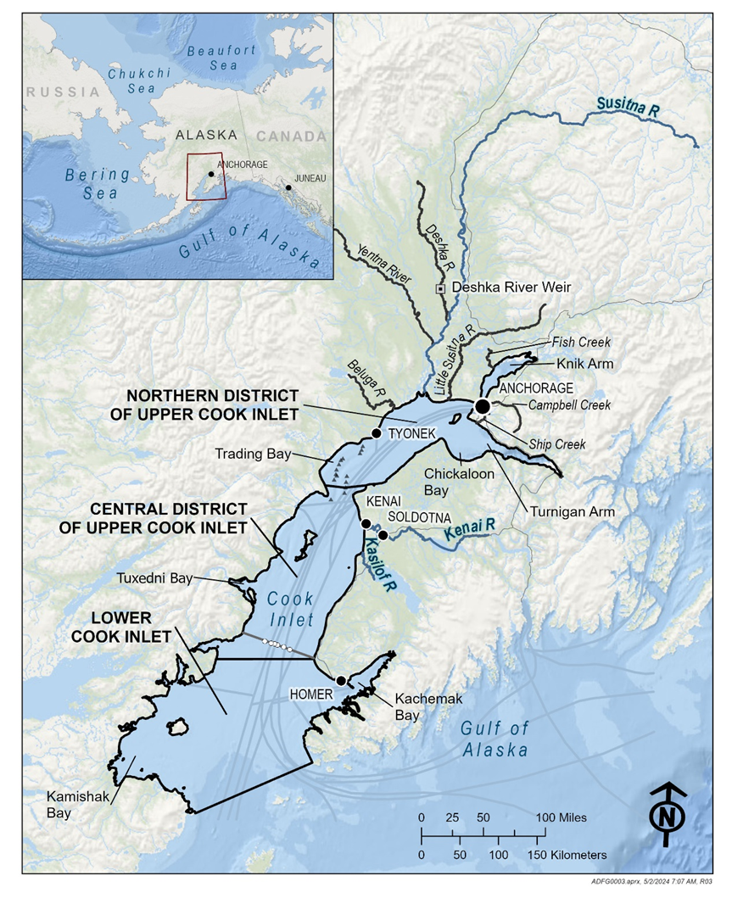

Figure 1. Geospatial representation of Cook Inlet in the North Gulf of Alaska.

**Notes:** In this report, Cook Inlet is broken into 3 areas which are used to describe geographic locations, aligning with ADF&G regulatory areas: the Northern District of Upper Cook Inlet, the Central District of Upper Cook Inlet, and Lower Cook Inlet. Data concerning Chinook and sockeye salmon from the rivers highlighted in blue were utilized in our analysis. Fish returning to these river systems overlap with CIBW’s historic range and showcase notable Chinook and sockeye salmon runs, each with annual run sizes surpassing 25,000 fish. Cities, towns, and roads are plotted as black dots. Grey tracks through Cook Inlet are shipping lanes, small triangles are drill platforms, and the grey line with white dots is the Offshore Test Fishery (OTF).

Figure 2. Cook Inlet Beluga Whale Abundance, 1994 to 2022.

Notes: The dashed vertical line marks the year the harvest moratorium was established, while the red vertical lines represent the standard deviation of the estimate.

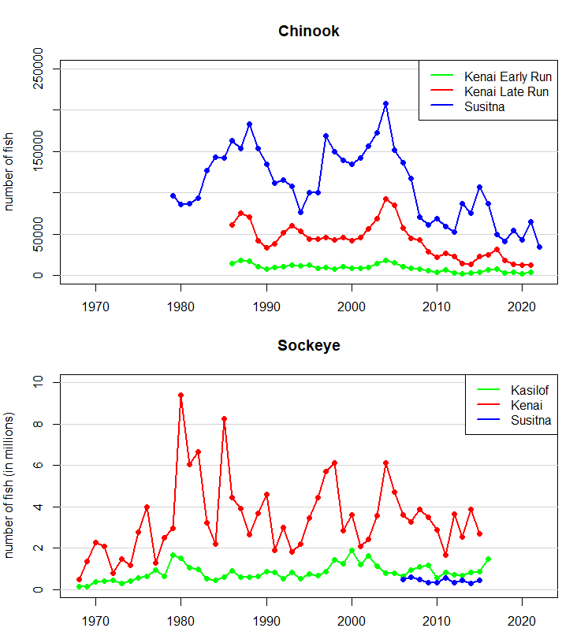

Figure 3. Annual run sizes for Chinook and sockeye salmon in major river systems within Upper Cook Inlet.

Figure 4. Average biomass per individual commercially harvested salmon in Upper Cook Inlet, 1975–2021.

Figure 5. Biomass of salmon by species, district, and year, used as indices of prey availability for beluga whales in Upper Cook Inlet.

Figure 6. Salmon catch rates in July at the offshore test fishery site located west of Anchor Point, 1979–2022.

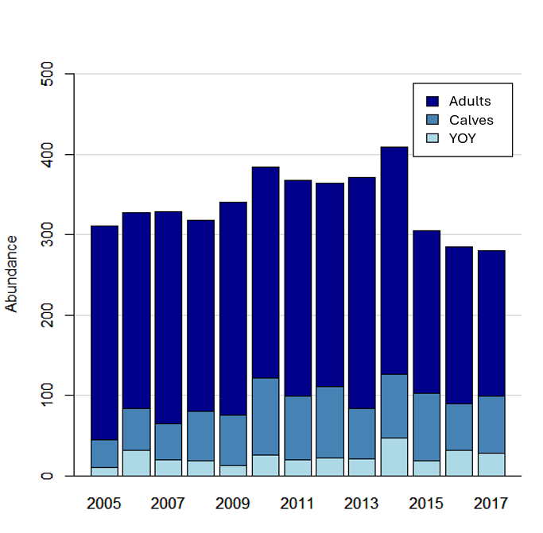

Figure 7. Cook Inlet beluga whale abundance by age class, 2005–2017, as estimated by our integrated population model.

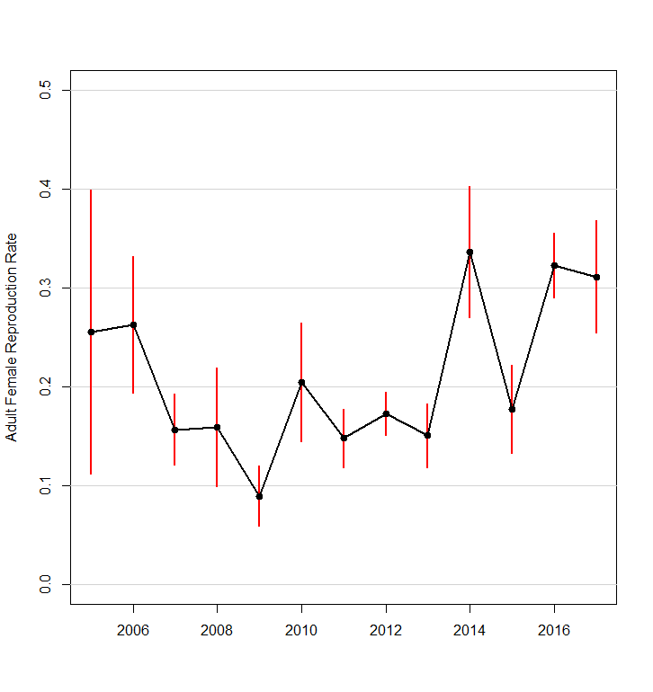

Figure 8. Annual adult female reproduction rate of Cook Inlet beluga whales from 2005 to 2017, as estimated by our integrated population model.

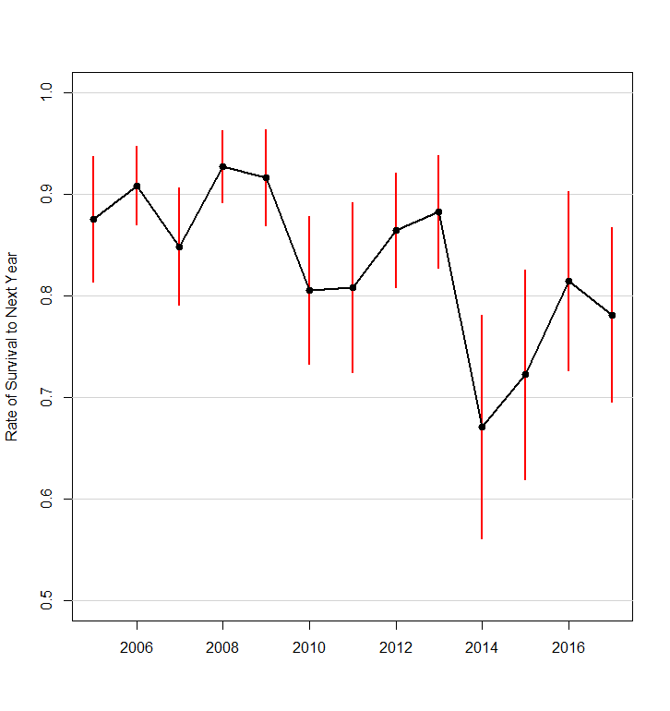

Figure 9. Annual survival rate of Cook Inlet beluga whales across all age classes from 2005 to 2017, as estimated by our integrated population model.

Figure 10. Biomass of salmon by species and district from 2005 to 2017, used as indices of prey availability for beluga whales in Upper Cook Inlet.

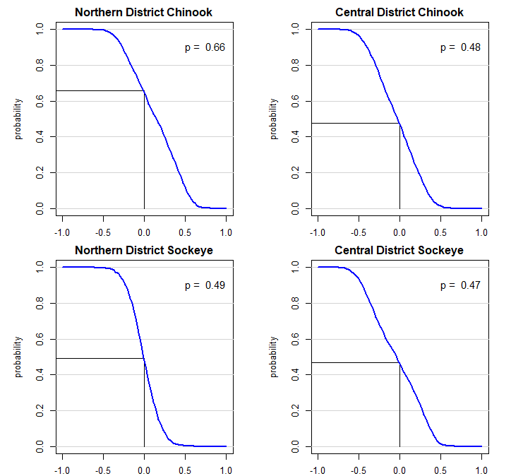

Figure 11. Inverse cumulative distribution functions showing our level of confidence that the Pearson correlation between the biomass of select salmon runs and CIBWs’ rate of reproduction the next year exceeds any value.

Note: The value in the top right corner indicates the confidence level that the two variables are positively correlated (i.e., the probability that the Pearson correlation between the biomass of select salmon runs and CIBWs’ reproduction rates in the following year exceeds zero).

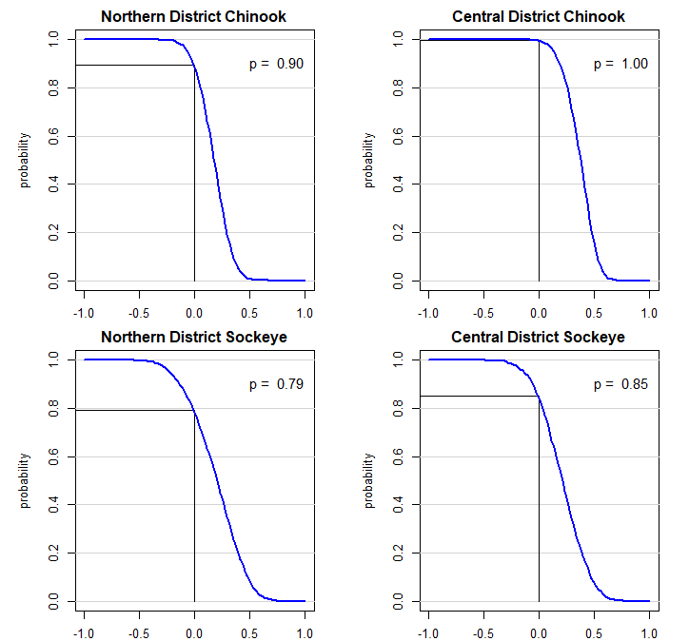

Figure 12. Inverse cumulative distribution functions showing our level of confidence that the Pearson correlation between the biomass of select salmon runs and CIBWs’ rate of survival to next year exceeds any value.

Note: The value in the top right corner indicates the confidence level that the two variables are positively correlated (i.e., the probability that the Pearson correlation between the biomass of select salmon runs and CIBWs’ rate of survival to next year exceeds zero).

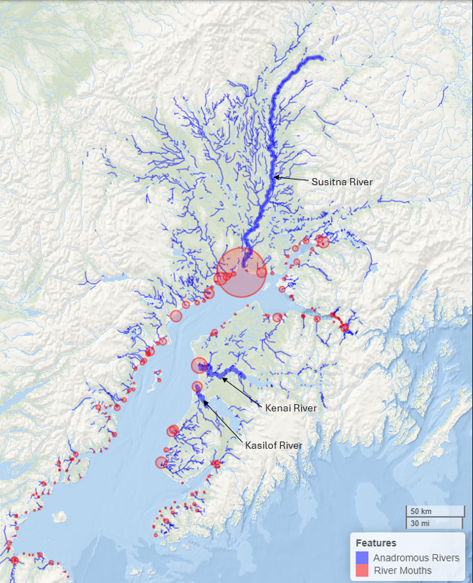

Figure 13. Distribution of anadromous rivers surrounding Cook Inlet.

Note: The size of the red circles at river mouths is proportional to the total length of anadromous rivers listed in ADF&G’s Anadromous Waters Catalog (Giefer and Graziano, 2023) that flow into each respective river mouth.

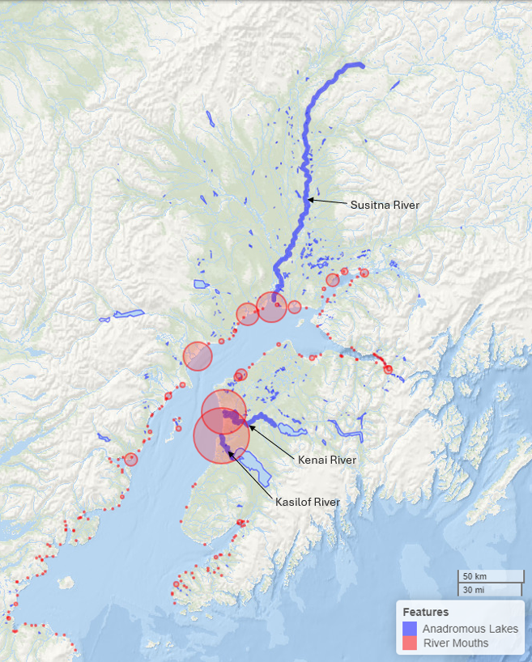

Figure 14. Distribution of anadromous lakes surrounding Cook Inlet.

Note: The size of the red circles at river mouths is proportional to the total area of anadromous lakes listed in ADF&G’s Anadromous Waters Catalog (Giefer and Graziano, 2023) that flow into each respective river mouth.

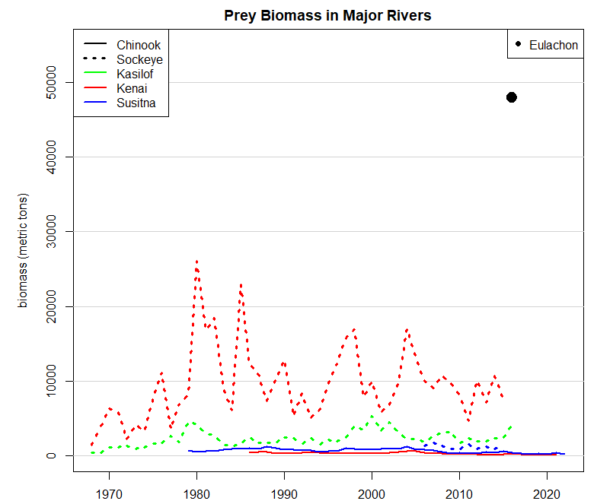

Figure 15. The annual biomass of select CIBW prey species in major rivers within Upper Cook Inlet.